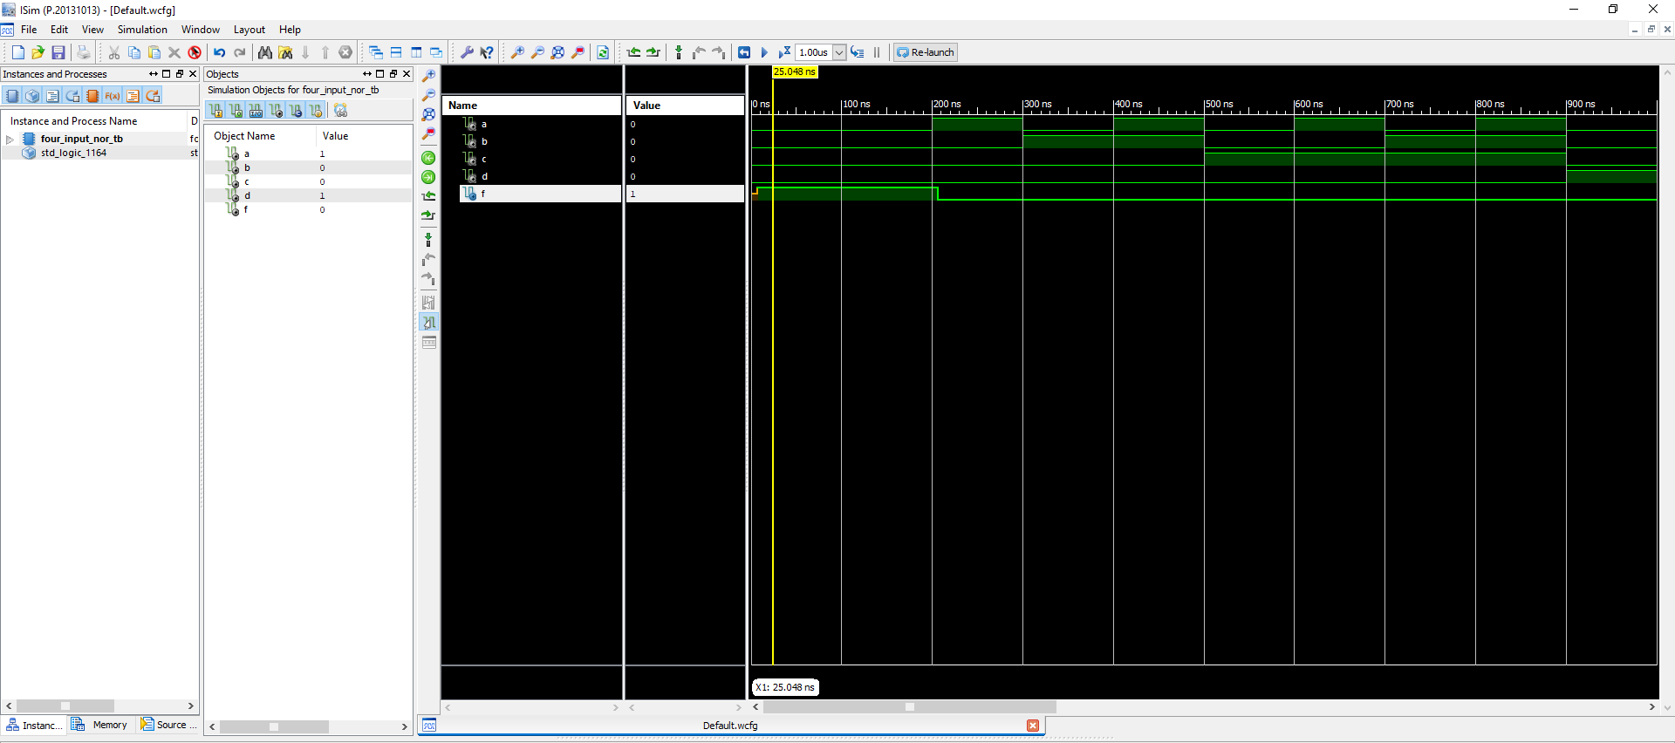

**Figure 1 Four Input NOR**

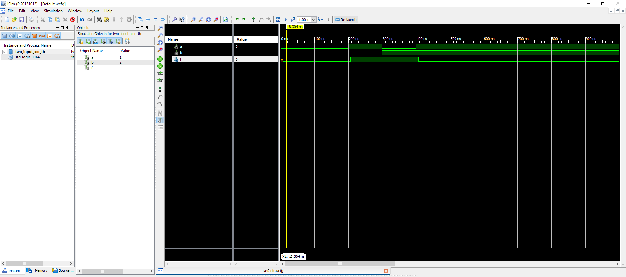

**Figure 2 Two Input XOR**

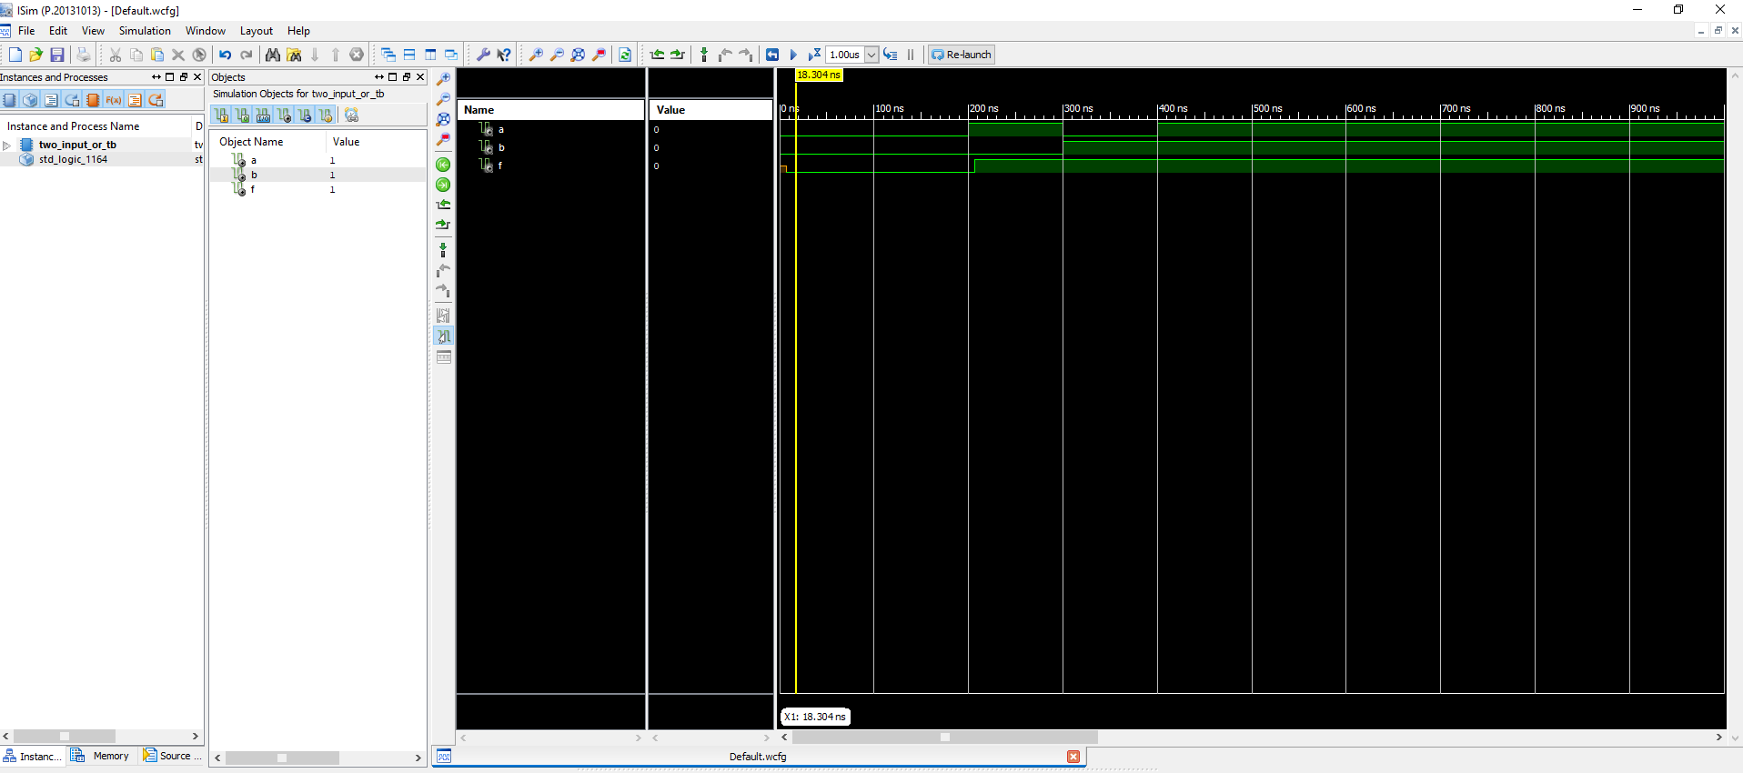

**Figure 3 Two Input OR**

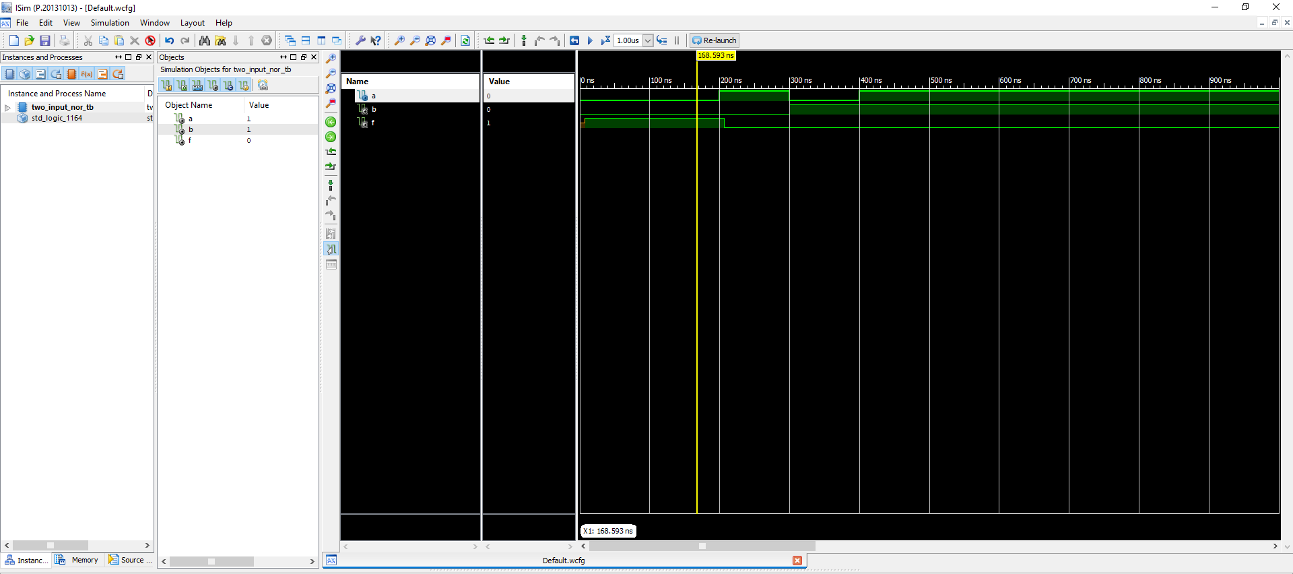

**Figure 4 Two Input NOR**

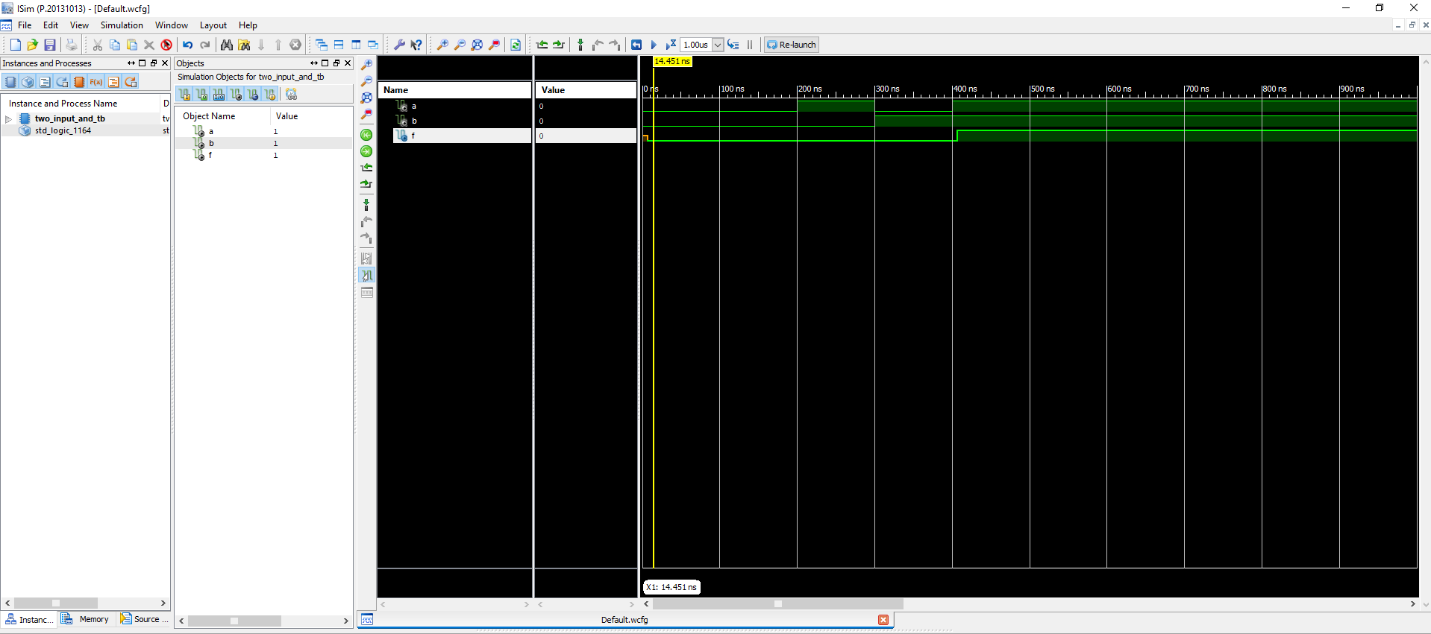

**Figure 5 Two Input AND**

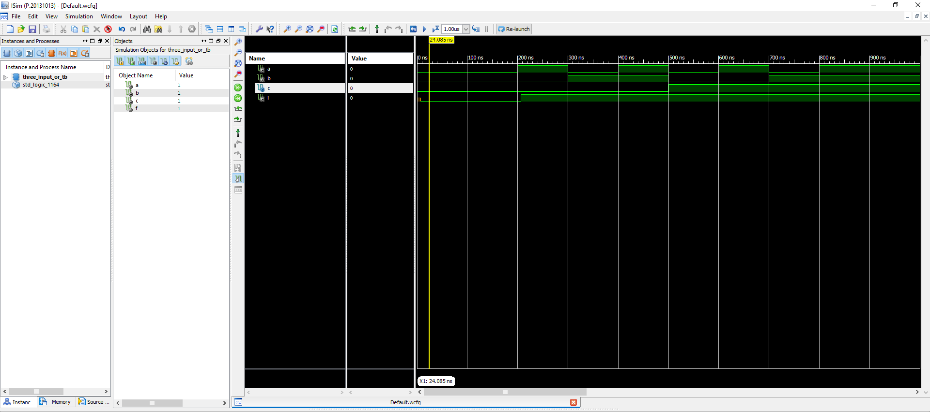

**Figure 6 Three Input OR**

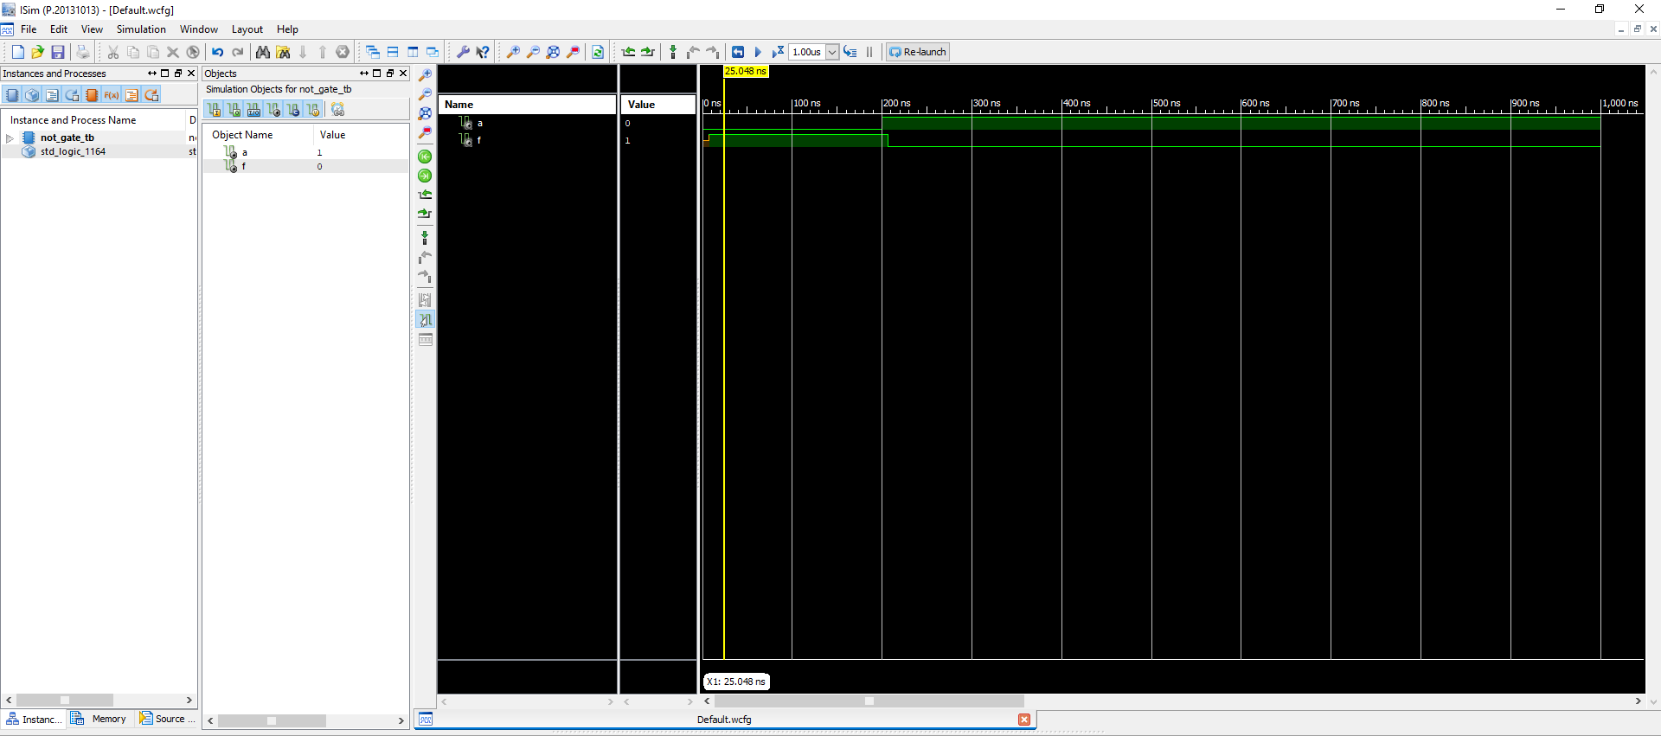

**Figure 7 NOT Gate**

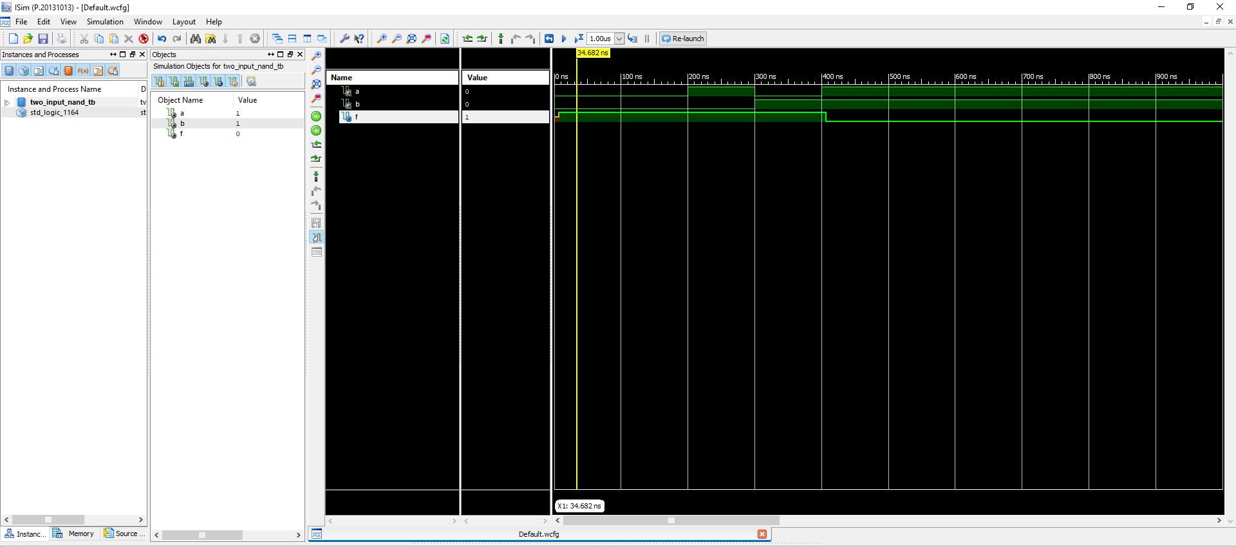

**Figure 8 Two Input NAND**

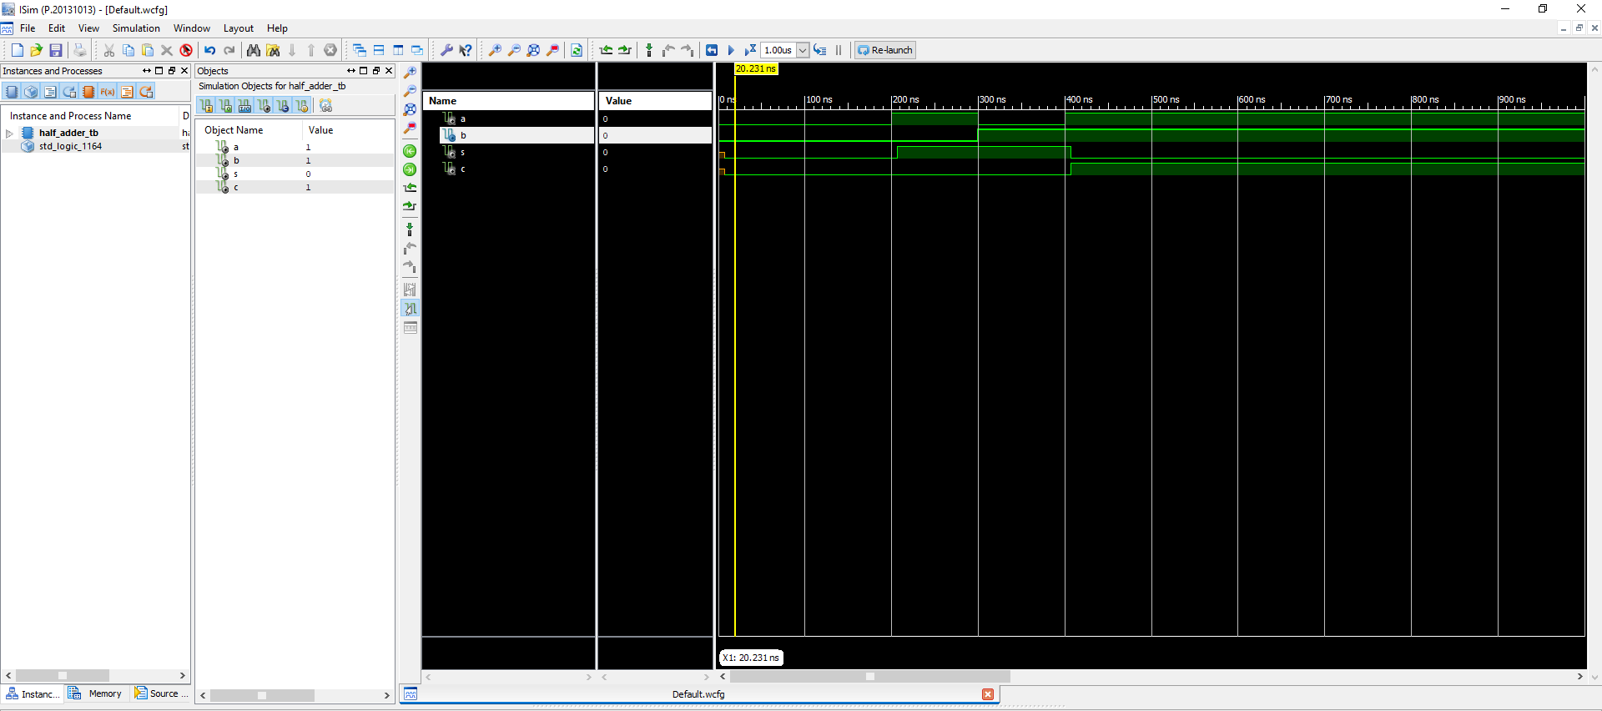

**Figure 9 Half Adder**

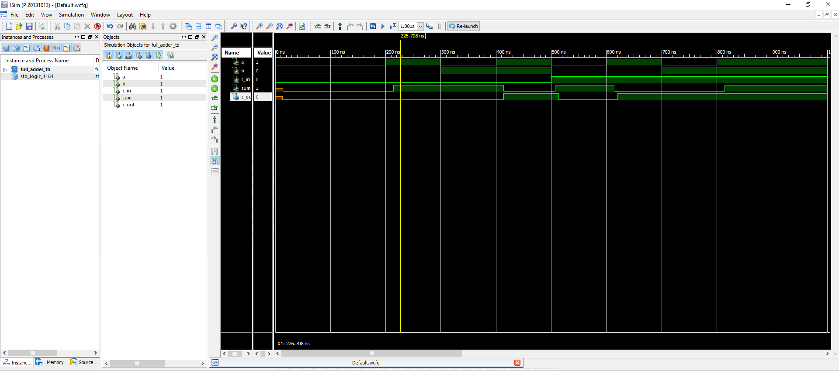

**Figure 10 Full Adder**

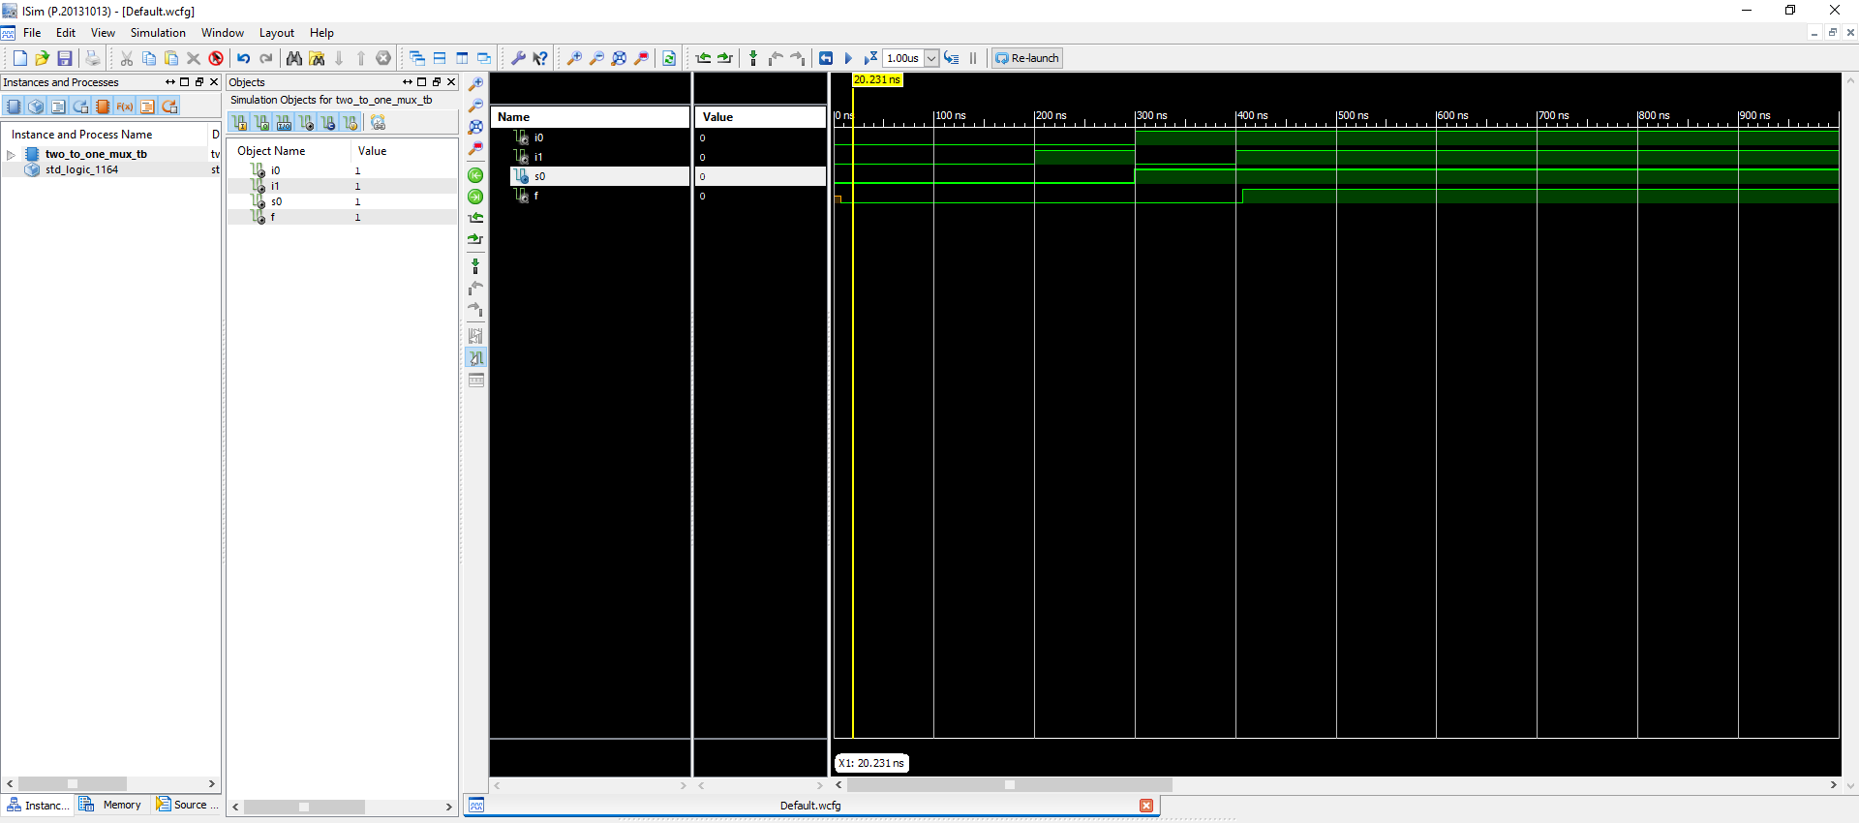

**Figure 11 Two Input Multiplexer**